A PROJECT REPORT
ON
“Soletude – An eCommerce Business Startup for Footwears”



Instructor Name: Conducted By:
Ms. Ramsha Khalid
Usman Ashfaq Abdullah Wasif(2025-CS-198)
Course Name: Faizan Ahmed(2025-CS-194)
AICTL M. M. Shoaib(2025-CS-201)
Amama Ishaq(2025-CS-209)
Dua Javaid(2025-CS-211)

Date: 11/10/2025

Table of Contents
Executive Summary 2
Project Objectives and Scope 2
Site Structure and Navigation 3
Design Choices 4
Assets Used 5
How to Run / Publish the Website 6
Reflection (Learning & Improvements) 6
Live Website URL 7
Website Interface 7
Inventory Management 12
Monthly Sales 13
Customers’ Orders 14
Marketing Expense 15
Feedback Analysis 16
Conclusion 17

Executive Summary

This project presents the design and development of a professional website for Soletude, a footwear business start-up aimed at delivering premium-quality and stylish footwear. The website serves as a central digital platform to communicate the brand’s identity, showcase products and provide essential business information to potential customers.
Developed using semantic HTML and external CSS, the project emphasizes a layout, clean navigation and modern design principles. Supporting documentation, including this Word report, an Excel data workbook and presentation slides, ensures consistency, clarity and professional project delivery.

Project Objectives and Scope

Objectives
The primary objectives of this project are:
- To design and publish a professional website for a footwear start-up brand.
- To establish a strong digital identity for Soletude.
- To apply HTML, CSS and website design techniques in a real-world context.
- To demonstrate proper project documentation and version control practices.
- To integrate business presentation with technical web development skills.

Project Scope
The scope of this project includes:
- A static business website developed using HTML and CSS.
- Multiple webpages including Home, About, Featured products, Trending products, Menu bar, Contact, Various categories, Account, Cart and Subscription Bar to stay connected.
- Focus on fronted design and user experience.
- Suitable for a small to medium footwear start-up.
- The project can be expanded in future to include e-commerce functionality and backend systems.
- The product gallery is featured with the ratings of each product for customer satisfaction and trustability.

Site Structure and Navigation

The website is structured to ensure clarity, accessibility and ease of navigation for users.

Website Pages
- Home Page
Introduces the Soletude brand, highlights featured products and trending footwear articles, presents the brand’s tagline and identity, showcases menu on top with brand logo, categories along with their sub-categories in drop down, cart icon to access the cart page, account icon to access customer’s account login and sign-up and brand’s about in the footer that showcases subscription bar, contact info and customer service information.
- Cart Page
Displays shopping review along with subtotal, shipping fee, products details and checkout bar.
- Account Page
This page showcases and interface where user can easily sign up to their new customer account or can login if they already have an account.
- Products / Services Page
Displays footwear categories that include New Arrivals (with sub categories of winters, limited edition and premium designs), Men (with sub categories sneakers, sports shoes, formal shoes and boots), Women (with sub categories heels, party wear, sneakers and sandals), Kids (with sub categories school shoes, joggers and crocs), Wedding Classics (with sub categories bridal heels and groom shoes), and accessories (i.e. shoe polish, shiner and socks).
- Gallery / Samples Page
Showcases high quality images of footwear products along with their price and ratings for customer satisfaction.
Navigation Design
A consistent navigation bar is used to allow users to move easily between sections, improving overall user experience.

Design Choices

Typography
A clean, modern serif font i.e. Poppins is used throughout the websites to ensure readability and a professional appearance.

Color Scheme
The website uses a minimal color palette consisting of:
- Black and White for a premium and elegant look with a little touch of golden-yellow to make it look more attractive.
- Neutral accent tones to complement footwear aesthetics.
This color section reflects sophistication, durability and trust-key qualities for a footwear brand.

Layout of the website
- Semantic HTML structure.
- External CSS for styling consistency.
- Flexbox and Grid layouts along with padding and margins for major sections.
- Proper scaling and alignment to maintain visual hierarchy.
- All the products images placed with fixed dimensions to make an overall neat look.
- Dropdown effect used in menu to access all the categories and sub categories in a user-friendly way.
- An overall white background is used to make the website look elegant.

Assets Used

Images
- Footwear products images.
- Brand logo of Soletude.
- Cart Icon
- Account / profile icon.
All images are either self-created or sourced from royalty-free platforms and are used strictly for educational purposes.

Data Sources
- Product names, categories and pricing data were created specifically for this project.
- Business content is original and aligned with the start-up concept.

How to Run / Publish the Website

To access and run the website:
- Download the project files from the GitHub repository.
- Open the index.html file in any modern web browser.
- Ensure all the CSS files are properly linked.
- The website can be published online using GitHub pages for live preview.

Reflection (Learning & Improvements)

Learning Outcomes
This project provided valuable experience in transforming a business idea into a functional digital product. It strengthened understanding of HTML semantics, CSS styling, designing and layouts and professional documentations. Additionally, it enhanced skills related to teamwork, planning and presenting a business concept in structured and professional manner.

Future Improvements
- Integration of an online shopping cart.
- Backend database and user authentication.
- To create a fully responsive website.
- Online payment gateway.
- Customer reviews and feedback system.
- Improved accessibility features.

Live Website URL

The LIVE website can be accessed by this URL:

Website Interface

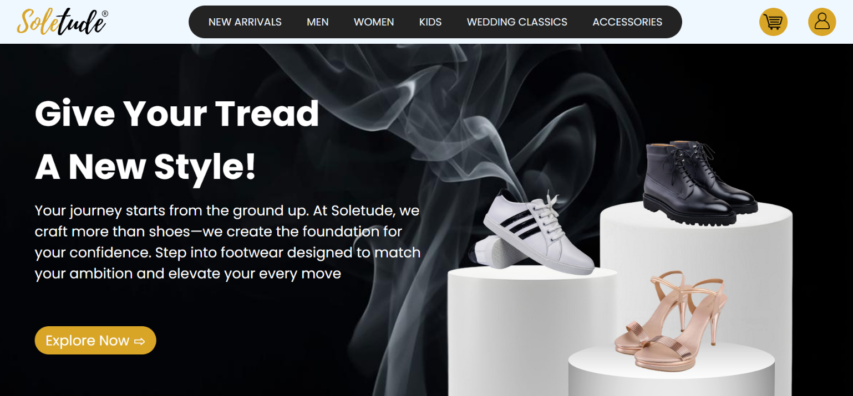

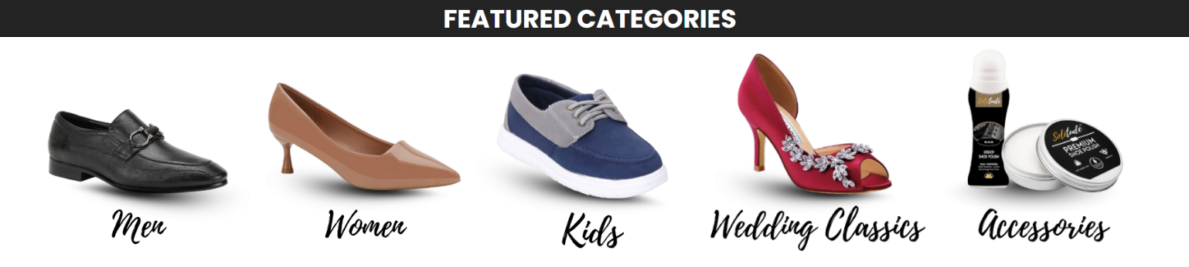

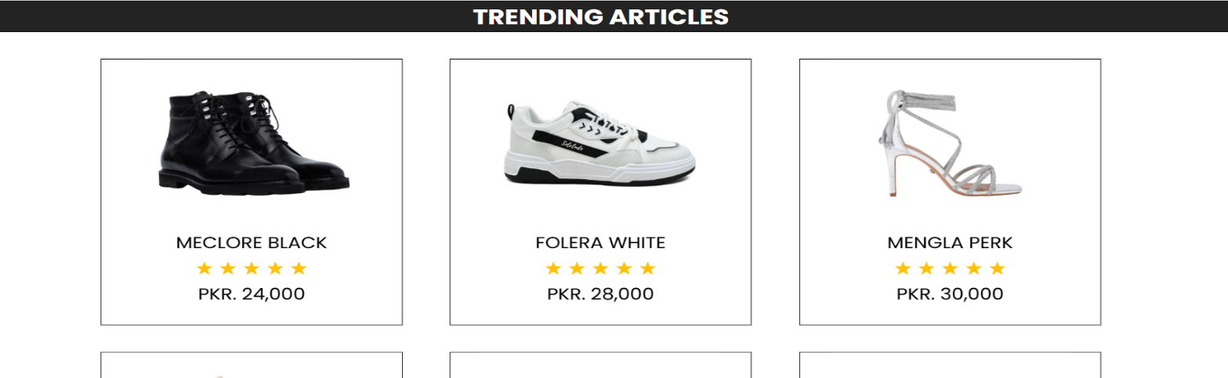
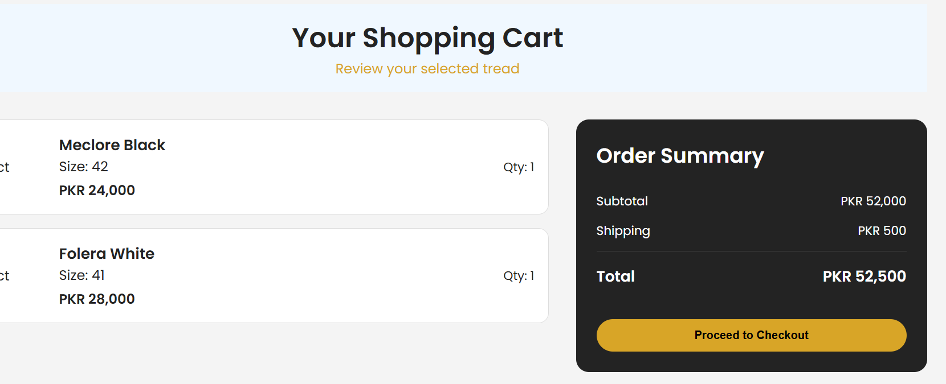

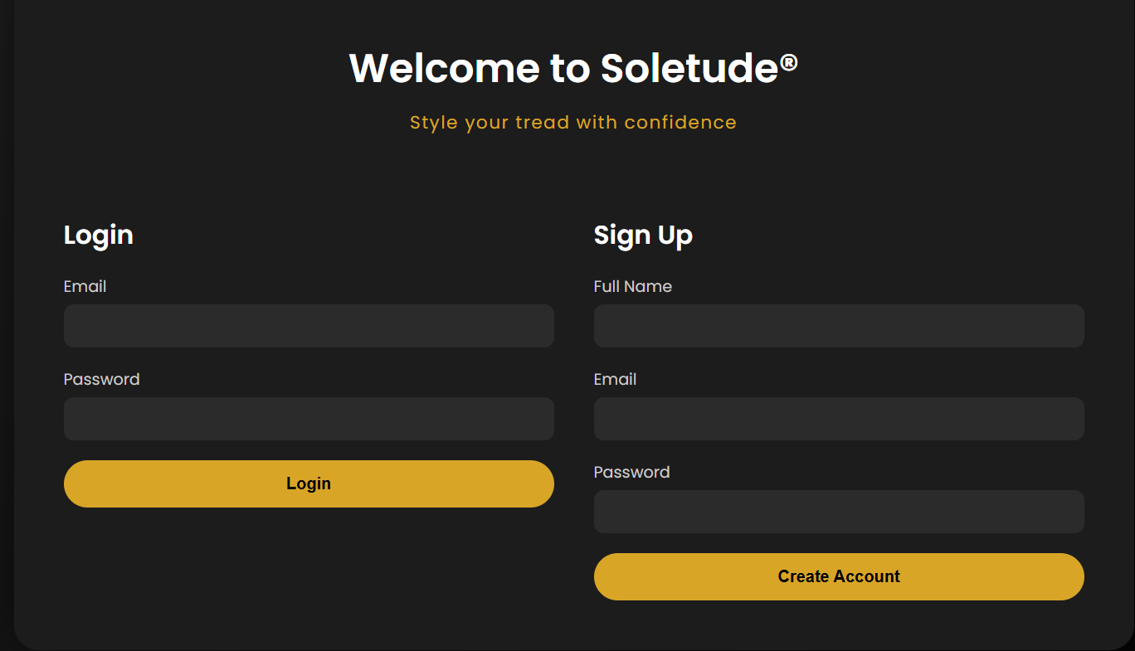

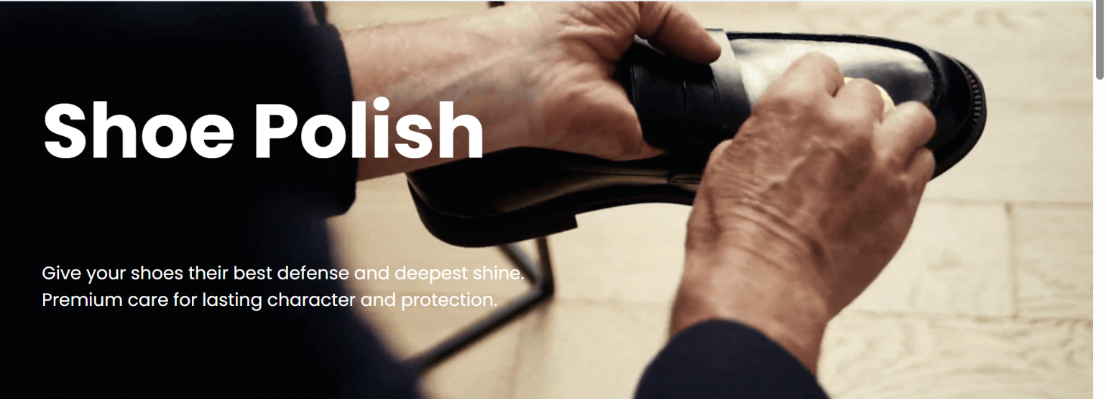

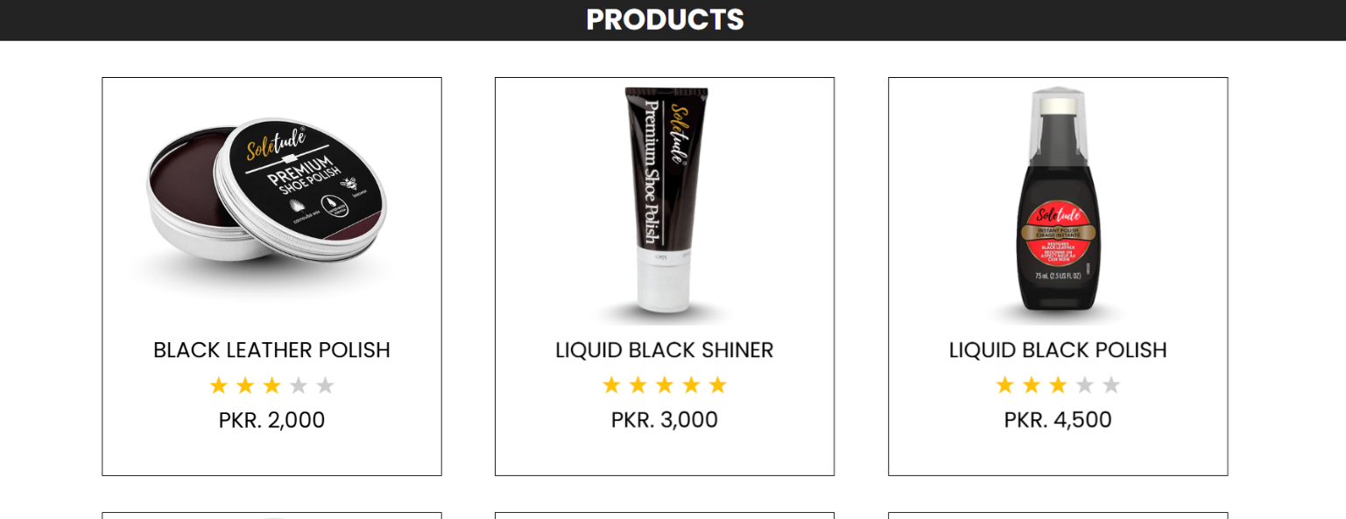

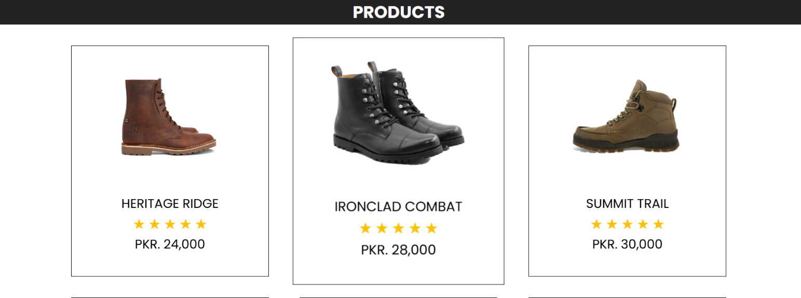
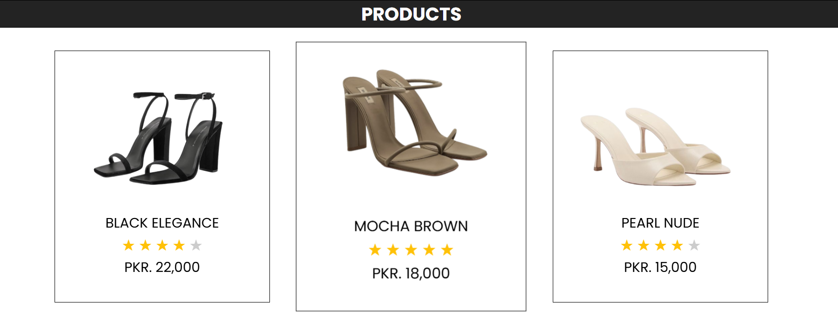

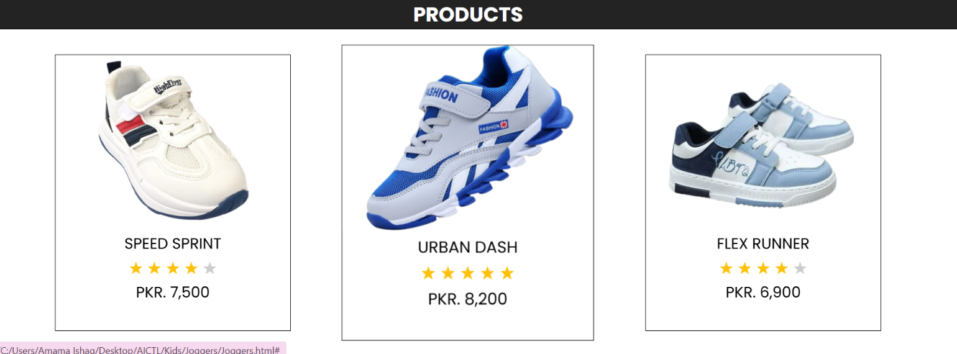

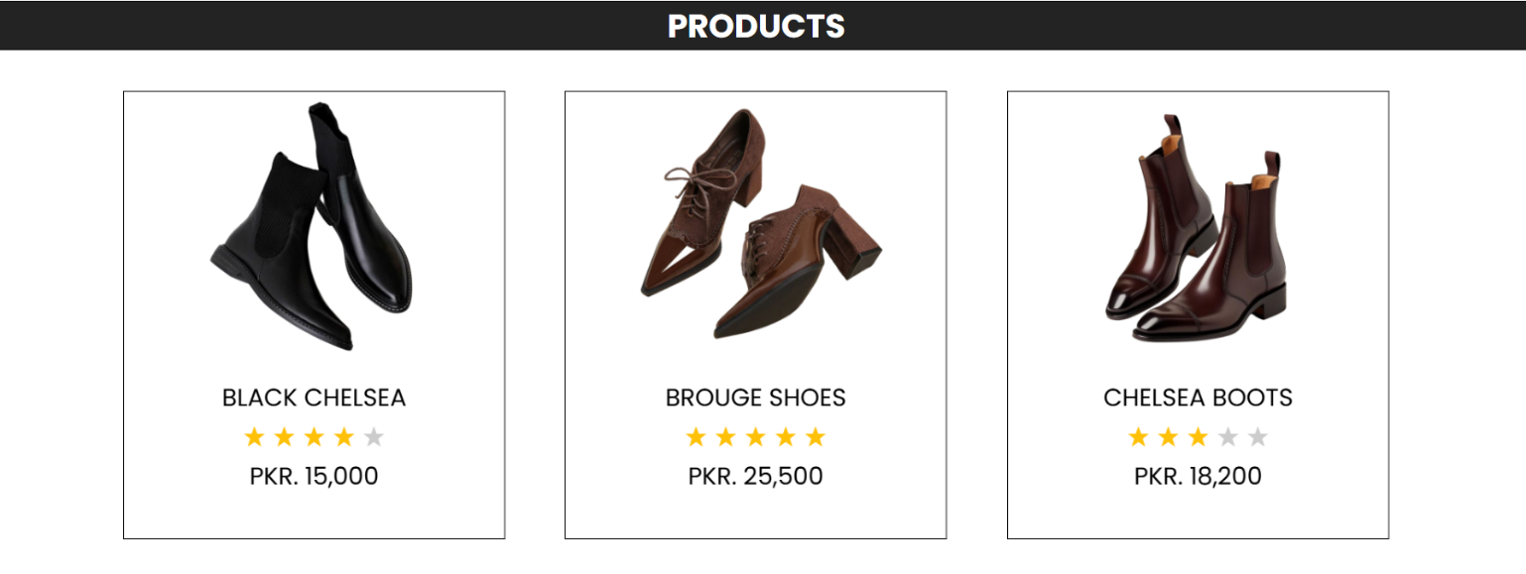

Inventory Management

- The total stock of 2,616 units is distributed across multiple product categories, showing a balanced inventory structure.
- Accessories, Men, and Women categories hold the largest shares, each exceeding 500 units, followed by Kids with 405 units.
- Wedding Classics contribute a moderate portion, while Premium Designs and Limited-Edition items represent smaller, niche segments.
- Winters has the lowest stock level, indicating seasonal or limited demand.
- Overall, the distribution reflects a mix of high-demand core products and specialized offerings.

Monthly Sales

- The bar chart illustrates monthly sales performance from January to May.
- Sales show an overall increasing trend, with a noticeable peak in February, followed by relatively stable figures through March and April.
- May maintains strong performance, indicating consistent demand over the period.
- Overall, the data reflects steady sales growth with minor fluctuations across the months.

Customers’ Orders

- Oxford shoes and leather heels record the highest sales figures, indicating strong customer preference for formal and premium footwear options.
- Lazy leather loafers and court shoes also demonstrate solid demand, reflecting consistent interest in both casual-formal and classic styles.
- In contrast, categories such as black loafers, chunky lace-ups, flats and sandals show comparatively lower sales, suggesting more limited customer demand in these segments.
- Overall, the data indicates that customers prioritize elegant and formal shoe styles over casual or seasonal footwear, providing valuable insight for inventory planning and future product focus.

Marketing Expense

- The marketing expense data shows a close comparison between the budget allocated and the actual expenditure in PKR across all months.
- In most months, actual marketing expenses remain near the allocated budget, indicating effective financial planning and control.
- Higher spending is observed in peak months, particularly around Months 3 and 8, where actual expenses slightly exceed the budget due to increased promotional activities.
- Several months, such as Months 2, 5, and 12, show actual expenses below the allocated budget, reflecting cost efficiency and reduced marketing needs.
- Lower allocations and expenditures are recorded during off-peak periods, suggesting strategic adjustment of marketing efforts.

Feedback Analysis

- The feedback analysis chart illustrates customer ratings on a scale of 1 to 5 across multiple observations.
- Overall ratings remain above average, indicating generally positive customer satisfaction.
- The feedback starts at a higher rating, followed by slight fluctuations over time, showing varying customer experiences.
- Several mid-period points maintain stable ratings around 4, reflecting consistent service or product quality.
- Minor declines at certain points suggest occasional areas where customer expectations were not fully met.
- In summary, the feedback trend reflects satisfactory performance overall, with opportunities for enhancement to achieve more consistent high ratings.

Conclusion

The Soletude Footwear Business Start-up Website successfully meets all project requirements by combining technical web development skills with professional business presentation. The project demonstrates how a start-up brand can establish a strong digital presence through thoughtful design, clear structure, and consistent documentation.

